**UNIVERSITY INSTITUTE OF ENGG. & TECHNOLOGY,**

**PANJAB UNIVERSITY, SECTOR-25, CHANDIGARH**



**INNOVATIVE PRODUCT DESIGN** *(SUBJECT CODE- IPD201)*

**PROJECT REPORT**

**TITLE OF THE PROJECT** - *VISUAL IMPAIRMENT AID DEVICE*

**SUBMITTED BY -** **NIKHIL GOGNA** (MECH-UE189050)

**MANISH** (MECH-UE189047)

**MANAN MITTAL** (MECH-UE189046)

**SAHIL SURYAVANSHI** (MECH-UE189066)

**BATCH -** B.E. MECHANICAL (2018-22)

**SUBMITTED TO -** DR. MANU SHARMA

DR. AMIT THAKUR

ER. SANDIP TREHAN

**ACKNOWLEDGEMENT**

I would like to express my deepest appreciation to all those who provided me the possibility to complete this report. A special gratitude I give to our respected and learned guides, Dr. Manu Sharma (HOD Of Mechanical Dept, UIET) & Dr. Amit Thakur for their valuable help and guidance, we are thankful to them for the encouragement they have given us in completing the project. We are also grateful to respected Er. Sandip Trehan and our respected Director Savita Gupta for permitting us to utilize all the necessary facilities of the institution.

We are also thankful to all the other faculty & staff members of our department for their kind co-operation and help. Lastly, we would like to express our deep apperception towards our classmates and our parents for providing us the moral support and encouragement as well as funds.

**CONTENTS**

**TOPICS**  **PAGE NO.**

List of tables and figures………………………………………………………………….4

Introduction & Background...…………………………………………………………..5-6

Literature Review……………………………………………………………………….7-8

Challenges to overcome & Problem statements……………………………………..........9

Purpose of our Project……………………………………………………………..............9

Project Design……………………………………………………………………….........10

Principles and Working of our device………………………………………………...11-13

Innovation……………….………………………………………………………………..14

Circuit Diagram…………………………………………………………………………...15

Calculations……………………………………………………………………………16-17

Programming Code……………………………………………………………….........18-22

Fabrication Schedule…………………………………………………………………...23-25

Gantt Chart………………………………………………………………………………...26

Cost Analysis………………………………………………………………………………27

Individual Work Distribution………………………………………………………...........28

Results & Discussion………………………………………………………………............29

Conclusion………………………………………………………………………………30-31

**LIST OF TABLES AND FIGURES**

**FIGURE NUMBER CONTEXT**

FIG 1 - Arduino UNO Board

FIG 2 - Ultrasonic Sensor

FIG 3 - Water Sensor

FIG 4 - Front View

FIG 5 - Back View

FIG 6 - Top View

FIG 7 - Side View

FIG 8 - Metal Clamps for fitment

FIG 9 - Ultrasonic Sensor

FIG 10 - Water Sensor Mounting

FIG 11 - Circuit Diagram

FIG 12 - Casing Design

FIG 13 - Final Casing Design

FIG 14 - Components of circuit

FIG 15 - All elements of circuit

FIG 16 - Final physical circuit

FIG 17 - Casing Template cut-out

FIG 18 - Ultrasonic Mounting

FIG 19 - Final fitting and finish of device

FIG 20 - Final Product

**INTRODUCTION**

Modern society is interlinked through a network of not only people, but their respective electronic devices as well. The devices permeate people’s lives so thoroughly that it is rare to see someone without an electronic device, be it a watch, a cellphone, a computer. Yet, these devices have not even touched the surface of what is possible. Recent research has delved into so called “smart” devices. These smart devices are ordinary, everyday gadgets that together with sensors widely broaden the possibilities of what is capable. However, there are just as many types of sensors as there are electronic devices. To communicate with each of these sensors through custom hardware is an expensive and tedious process. Hence, there is a need for a system that can flawlessly connect different sensors and make sense of this data.

**ARDUINO UNO :**

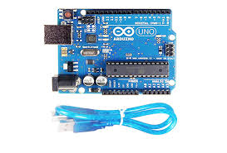Arduino UNO is an open-source microcontroller board based on the Microchip ATmega328P microcontroller and developed by Arduino.cc. The board is equipped with sets of digital and analog input/output (I/O) pins that may be interfaced to various expansion boards (shields) and other circuits.[1] The board has 14 Digital pins, 6 Analog pins, and programmable with the Arduino IDE (Integrated Development Environment) via a type B USB cable. It can be powered by the USB cable or by an external 9-volt battery, though it accepts voltages between 7 and 20 volts. The word "uno" means "one" in Italian and was chosen to mark the initial release of the Arduino Software. The Uno board is the first in a series of USB-based Arduino boards, and it and version 1.0 of the Arduino IDE were the reference versions of Arduino, now evolved to newer releases. The ATmega328 on the board comes preprogrammed with a bootloader that allows uploading new code to it without the use of an external hardware programmer.

FIGURE NO. 1

**ULTRASONIC SENSOR (HC-SR04) :**

Ultrasonic transducers or ultrasonic sensors are a type of acoustic sensor divided into three broad categories: transmitters, receivers and transceivers. Transmitters convert electrical signals into ultrasound, receivers convert ultrasound into electrical signals, and transceivers can both transmit and receive ultrasound. In a similar way to radar and sonar, ultrasonic transducers are used in systems which evaluate targets by interpreting the reflected signals. For example, by measuring the time between sending a signal and receiving an echo the distance of an object can be calculated. Passive ultrasonic sensors are basically microphones that detect ultrasonic noise that is present under certain conditions.

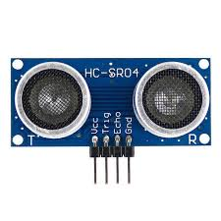

FIGURE NO. 2

**WATER SENSOR :**

A water sensor is an electronic device that is designed to detect the presence of water for purposes such as to provide an alert in time to allow the prevention of water leakage. A common design is a small cable or device that lies flat on a floor and relies on the electrical conductivity of water to decrease the resistance across two contacts. The device then sounds an audible alarm together with providing onward signaling in the presence of enough water to bridge the contacts. These are useful in a normally occupied area near any infrastructure that has the potential to leak water, such as HVAC, water pipes, drainpipes, vending machines, dehumidifiers, or water tanks.

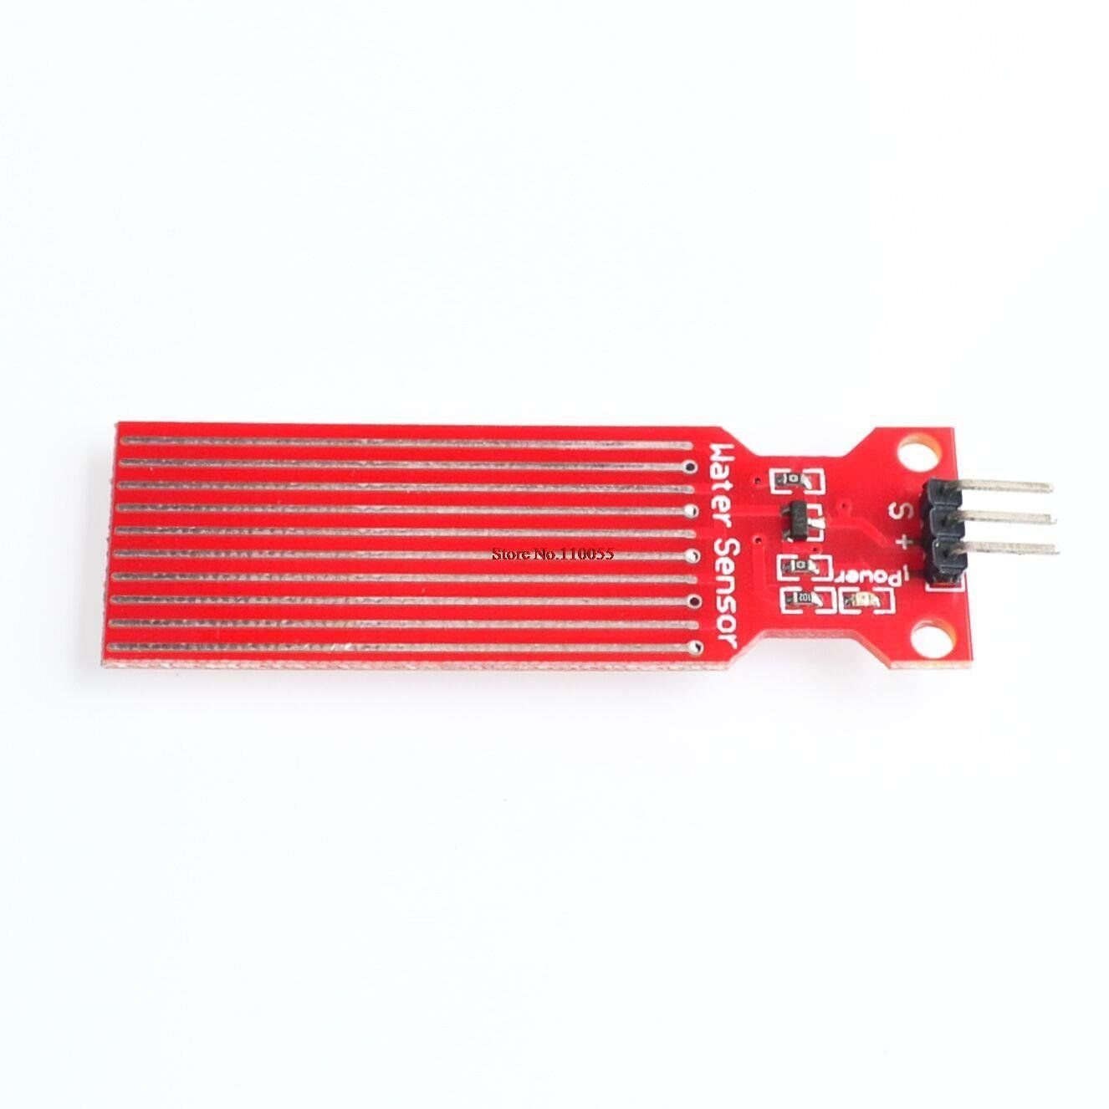

FIGURE NO. 3

**LITERATURE REVIEW**

Voice operated outdoor navigation system for visually impaired persons done by Somnath and Ravi (2012). Uses a stick equipped with ultra-sonic sensors, GPS. The stick contains GPS which will have SD memory card which used to store different locations. The user can set the location by GPS will guide the person to his/her destination. This system will also provide the speed and the remaining distance to reach the destination. When the ultra-sonic sensors detect any obstacle directly the buzzer will activate the vibration motor. This system can be classified as a low-cost system affordable by the user. The system uses the ARM processor which has more memory space, so that the operating speed is high. However, this system cannot operate indoors because there will be no signal for the GPS system. The accuracy of the GPS signal needs to be improved because it only can be controlled within 5 meters radios. Finally, the blind person needs to be trained on the system so that he or she can use it effectively. Shruti and Prof. A system done for using smart stick for blind people: obstacles detections, artificial vision and real time assistance via GPS. This system operates by using GPS, artificial vision system, obstacle detection. This system also contains ultrasonic sensors to detect the obstacles. Furthermore, this system include GPS system is to reach the required destination. Once any obstacle is detected or the destination is reached the voice circuit will activate providing certain type of voice. All these sub systems are connected to microcontroller which control the entire operation of the system. This system can be classified as a low-cost system. The accuracy of the artificial vision unit provides a high accuracy output for the user. In addition to that, the detection distance of the system is 15 meters. However, the designing complexity of the system make it difficult to design and understand. Another study in the same field to help blind people uses the pulse echo technique in order to provide a warning sound when detecting the obstacles. This technique is used by the United States military for locating the submarines. They used pulse of ultrasound range from 21 KHz to 50 KHz which hit the hard surface to generate echo pulses. By calculating the difference between signals transmit time and signal receiving time we can predict the distance between the user and the obstacles. This system is very sensitive in terms of detecting the obstacles. It has a detection range up to 3 meters and a detection angle between 0 degree to 45 degree. However, this system requires more power to operate because of the transmitter and receiver circuits. So, this system need to be redesigned to operate with less power consumption (Anon., n.d.). another study done by (Sung, Young, Kim and IN, 2001) for developing an intelligent guide stick for blind people used an intelligent CPU called MELDOG which uses artificial intelligence. It can identify the accurate position of obstacles using ultrasonic sensors and laser sensors. In order to identify the position the “map matching technique” was used by using the ultrasonic sensors. This system includes a DC motor controller which connected to the encoder. When the wheels rotate 18 degree the infrared sensors attached to both wheels will transmit the signal to the CPU in order to provide a location update. This system is an accurate detecting system can provide the user continuous update for detecting the obstacles with detection angle between 0 degree to 18 degree. However, this system is expensive and is complex in designing. It is heavy compared to other similar system. The weight of the system is around 5.5 Kg. The detection distance for the system is very low which is around 87.5 cm to 105 cm. a study done by (Jayant, Pratik and Mita, 2012) proposed a smart cane assisted mobility for the visually impaired. The system is based on normal ultrasonic sensors and ATMEL microcontroller. It operates with two rechargeable battery (7.4v) it can be recharged using USB cable or AC adaptor. The control unit is programmed using ATMEL AVR microcontroller ATMEGA328P microcontroller. Once any obstacles are detected vibration and buzzer will start in order to warn the user. This system is a non-complex system to use. It can cover a distance up to 3 meters and has the rechargeable feature of the buttery. Also, this system can be International Journal of Engineering Science and Computing, August 2018 18787 http://ijesc.org/ folded in small piece so that the user can carry it easily. However, this system has only one direction detection coverage and it is inaccurate in detecting the obstacles. All the studies which had been reviewed shows that, there are many types of smart sticks for blind people and all of them uses different techniques to give the required assistance for the blind person. However, the studies show that, using the ultrasonic sensors is an efficient solution to detect the obstacles with maximum range of 7 meters and 45-degree coverage. In addition to that, using a noncomplex microcontroller will help the blind person to use the devise (stick) easily and without any problems. Finally, the device should work for a long time with minimum power and it could be recharged. This system proposes a stick which uses ultrasonic sensors for detection and a microcontroller that controls the system without complexity. The detection angle is 180 degree. It is using a 12-volt lithium rechargeable battery. It is low cost and light weight system.

**CHALLENGES TO OVERCOME & PROBLEM STATEMENTS**

1. Physical movement is a challenge for visually impaired persons, because it can become tricky to distinguish where he is, and how to get where he wants to go from one place to another. To navigate unknown places, he will bring a sighted family member or his friend for support. In most of the cases, regular stick becomes handy for blind people. But in many situations, they prove to be of no use.
2. People find difficulties in detecting obstacles in front of them, during walking in the street, which makes it dangerous.
3. Even some of the earlier proposed smart sticks offer obstacle avoidance but fail to detect any pothole or water puddle.
4. One of the major challenges is to distinguish b/w human/animal kind of obstacle or car/wall kind obstruction.
5. All the other smart sticks need to be bought as a complete costlier package compared to already owned regular stick.

**PURPOSE OF OUR PROJECT**

Our project aims to design and implement an intelligent and universal assistance device for all the existing normal blind-sticks used by visually impaired people using Arduino, which can detect obstacles and hurdles including potholes and water puddles in the path and thus, provide the user with a quick stimulus as a combination of vibration and sound output.

**PRODUCT DESIGN**

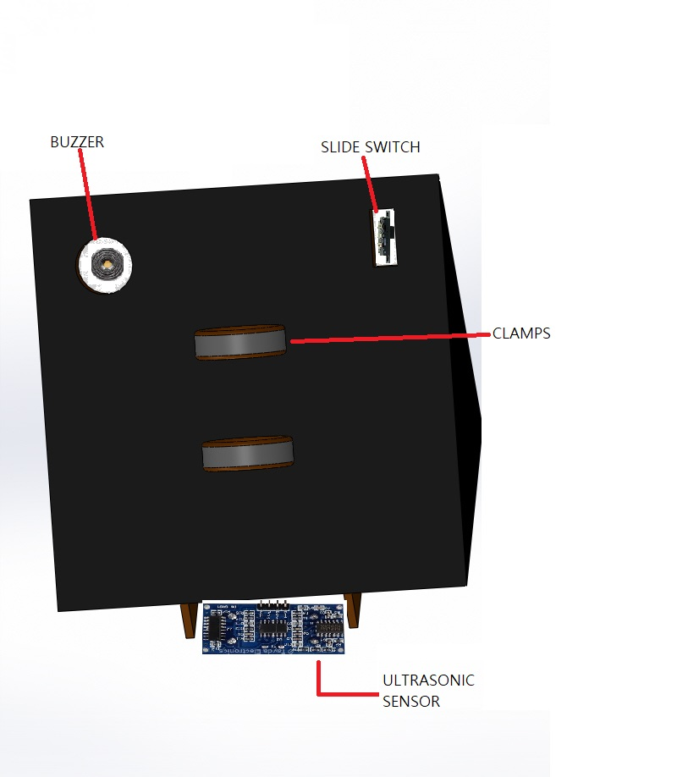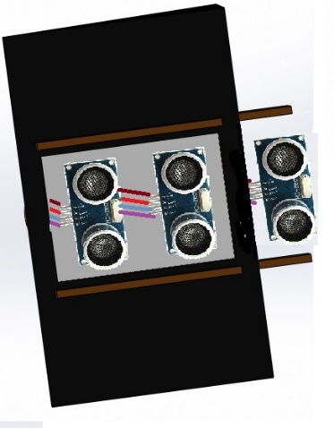

FIGURE NO. 5

FIGURE NO. 4

FIGURE NO. 7

FIGURE NO. 6

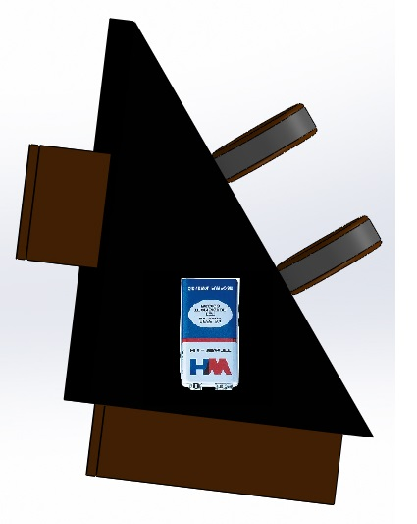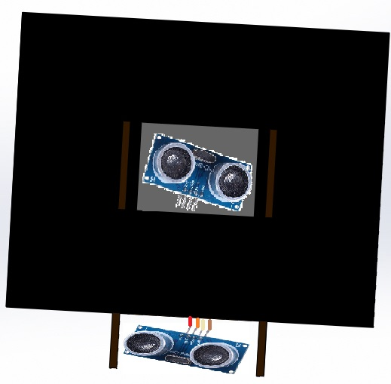

**PRINCIPLES & WORKING OF OUR DEVICE**

1. Universal fitment for all sticks:

This device can be easily fitted on any existing stick using simple Velcro tapes and regular stick can be turned into a advanced blind stick without the problem of heavy costs. Vibration motor can be fixed near to the handle grip of the stick because of which proper vibration stimulus can be provided to the user.

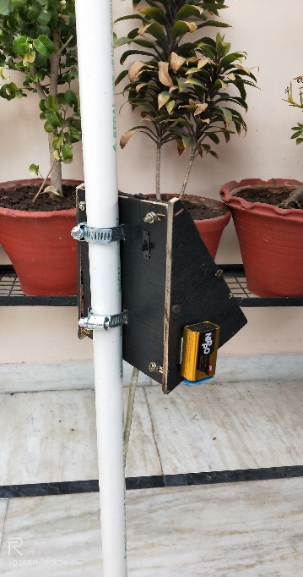

FIGURE NO. 8

1. For detecting obstacles as well as potholes:

The device is integrated with two ultrasonic sensors. Our proposed project first uses ultrasonic sensor to detect obstacles ahead using ultrasonic waves. The ultrasonic sensor in the front of the device identifies the obstacle in front of the person, whereas one more ultrasonic sensor which is mounted at an angle to the device, points towards the ground. This basically detects the presence of potholes on the path of the person. This sensor basically works by programming the arduino for the same input but with different constraints which means if more than a fixed distance (ideally 1m) is achieved by the sensor’s input, the buzzer will beep which implies it might be a pothole. This allows a person to know that there is a pothole in front of him.

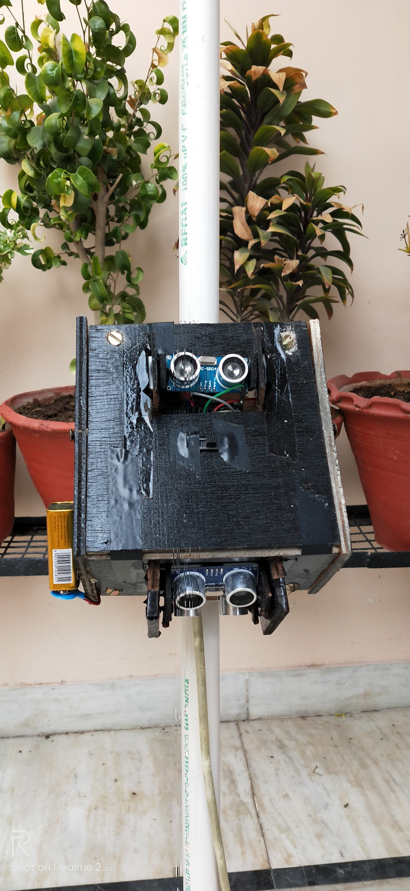

FIGURE NO. 9

3.) For detecting human obstacles:

Next comes the PIR sensor, it senses motion of a human or an animal body which might be coming in the way of the blind person. This sensor produce a different output than what was produced by the ultrasonic sensors because of which the person can distinguish that whether the obstacle is a person or car/wall.

4.) For detecting water on pathway:

Water sensor brick is designed for water detection, which can be widely used in sensing water on any surface, rainfall, water level, and even liquid leakage.

The sensor sends the data to the Arduino, which further calculates the presence of water and sends warning to the person, by the buzzer and vibration motor.

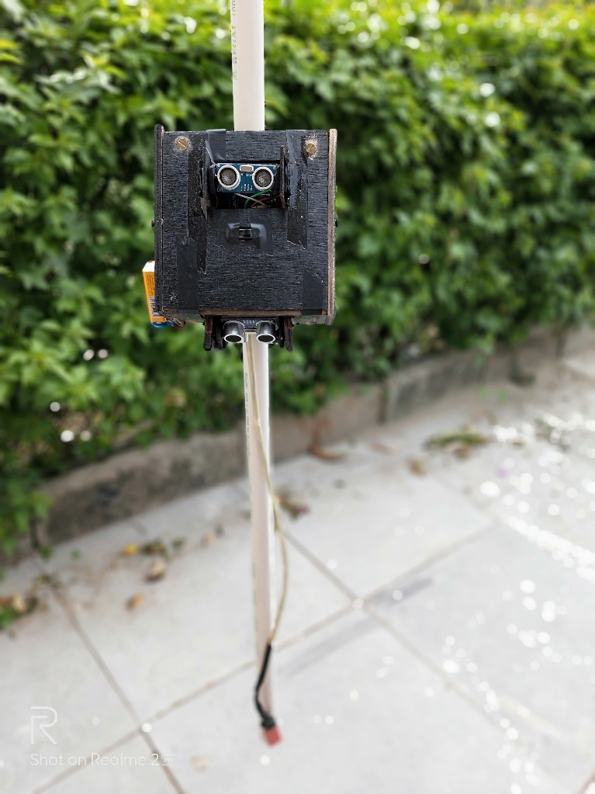

WATER SENSOR

FIGURE NO. 10

**INNOVATION REPORT**

* The 3rd ultrasonic sensor will be mounted in order to solve the issue where the prior design cannot detect the objects present the upper body level. (above the handle of the stick)
* We found that the triangular prism would be the best shape in order to be compact and proper housing can be given to all components.
* We came up with idea to heat seal the water sensor’s module with a rubber tubing, keeping just the safe parts in the reach of water or any other foreign particles.
* We came up with solution that one should be able to change the mounting angles of the ultrasonic sensors and modifying it manually for personal use.
* Mounting mechanism was finalized for all the sensors.
* We decided to use wooden board not more than of thickness 7mm for a robust and light-weight structure.
* We planned to use a switch for selecting modes:
  + - ONLY BLIND – Only sound alerts.
    - DEAF & BLIND – Only vibrations.
    - This will ensure the optimum and energy/ cost efficient use of the batteries of the device.
* We finalized to use metal clamps instead of Velcro straps to attach device to any stick.

**CIRCUIT DIAGRAM**

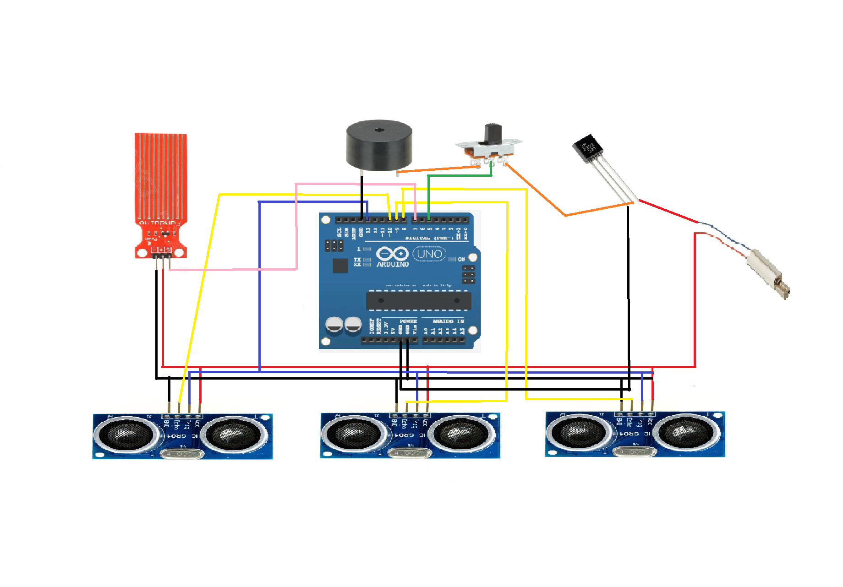

FIGURE NO. 11

**COMPONENTS:**

* Arduino Uno
* 3-UltraSonic Sensors
* Water Sensor
* Vibration Motor
* Buzzer
* 9V Battery (power supply)
* Jumper Wires
* Slider Switch
* Casing of the device including all fitments
* Breadboard

**CALCULATIONS:**

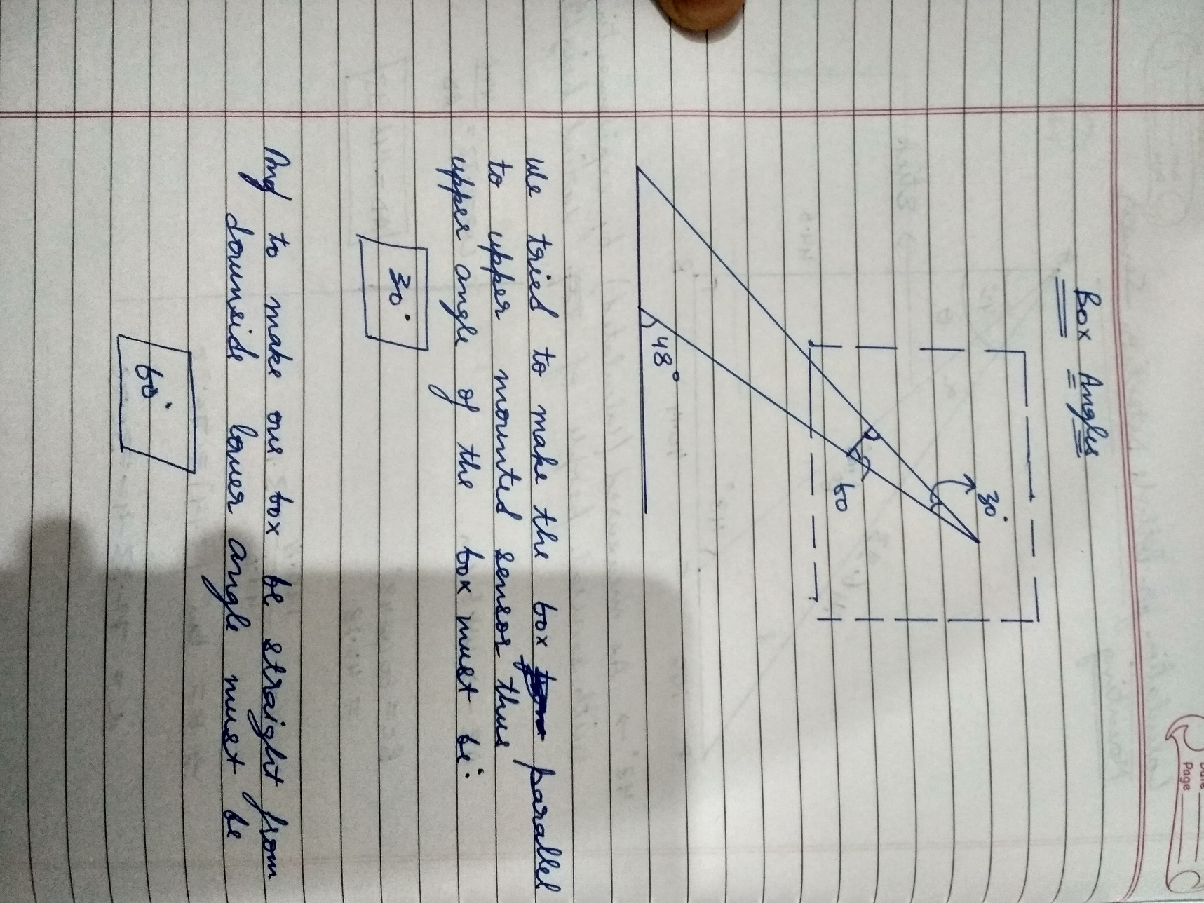

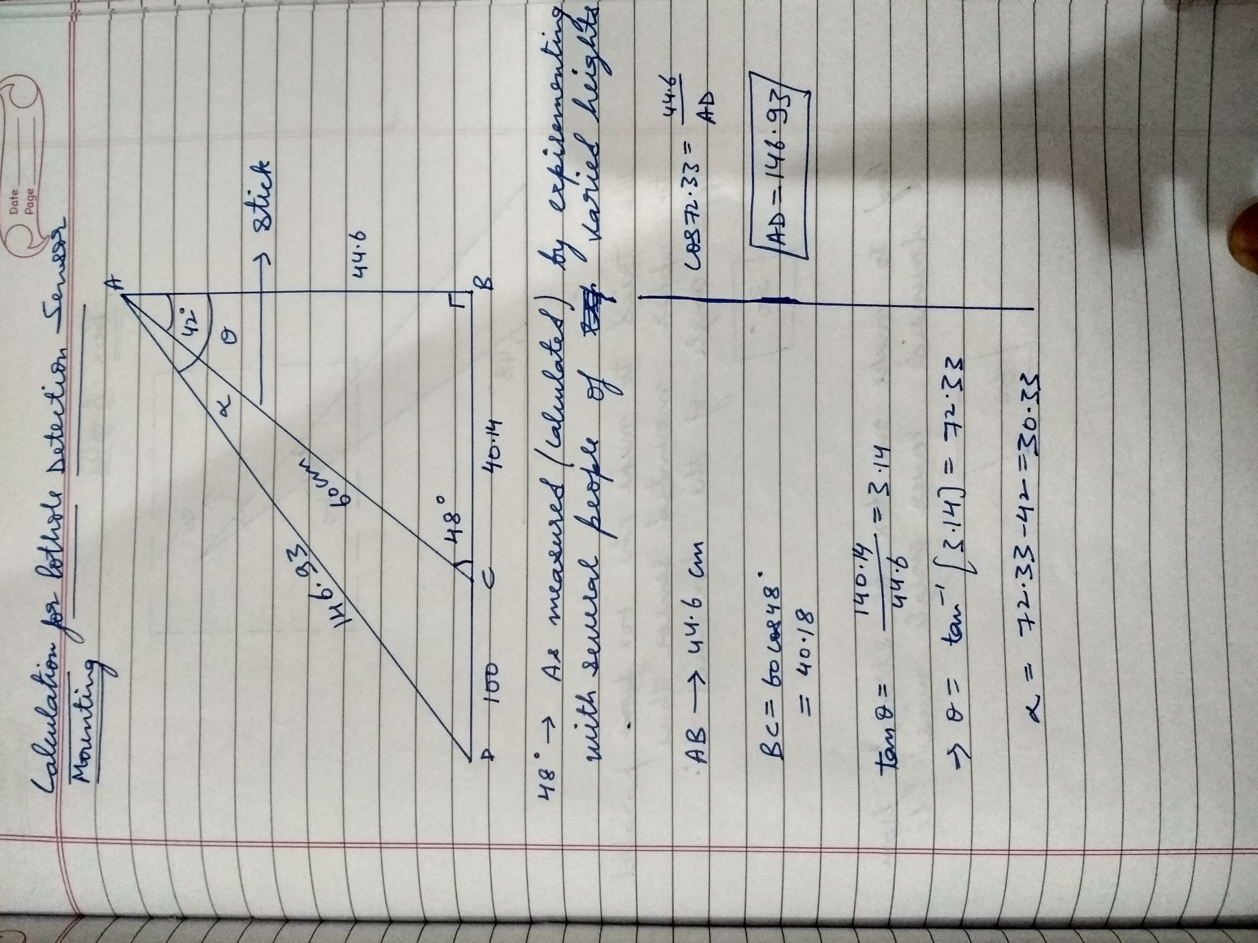

**PROGRAMMING CODE**

const int water=7;

const int trigpin=13;

const int echopin1=8;

const int echopin2=9;

const int echopin3=10;

const int buzz=5;

int check=0;

//check variable is included to neglect the output of upper ultrasonic sensor while both obstacle

detecting and upper gives their output as high

void setup()

{

pinMode(trigpin,OUTPUT);

pinMode(echopin1,INPUT);

pinMode(echopin2,INPUT);

pinMode(echopin3,INPUT);

pinMode(buzz,OUTPUT);

pinMode(water,INPUT);

Serial.begin(9600);

}

//function for obstacle avoiding ultrasonic sensor

void ultrasonic1()

{

int distance1;

int duration1;

digitalWrite(trigpin,LOW);

delayMicroseconds(20);

digitalWrite(trigpin,HIGH);

delay(100);

digitalWrite(trigpin,LOW);

duration1=pulseIn(echopin1,HIGH);

distance1=duration1*0.034/2;

if(distance1)

{ check=HIGH;

}

else

{

check=LOW;

}

if(distance1&lt;=100)

{

digitalWrite(buzz,HIGH);

delay(500);

digitalWrite(buzz,LOW);

delay(500);

}

}

//function for pothole detection ultrasonic sensor

void ultrasonic2()

{

int distance2;

int duration2;

digitalWrite(trigpin,LOW);

delayMicroseconds(20);

digitalWrite(trigpin,HIGH);

delay(100);

digitalWrite(trigpin,LOW);

duration2=pulseIn(echopin2,HIGH);

distance2=duration2*0.034/2;

if(distance2>=70)

{

digitalWrite(buzz,HIGH);

delay(200);

digitalWrite(buzz,LOW);

delay(200);

}

}

//function for water detection sensor

void water1()

{

if(digitalRead(water)==HIGH )

{

digitalWrite(buzz,HIGH);

delay(1000);

digitalWrite(buzz,LOW);

delay(2000);

}

else{

digitalWrite(buzz,LOW);

}

//function for upper hindrance

void ultrasonic3()

{

int distance3;

int duration3;

digitalWrite(trigpin,LOW);

delayMicroseconds(20);

digitalWrite(trigpin,HIGH);

delay(100);

digitalWrite(trigpin,LOW);

duration3=pulseIn(echopin3,HIGH);

distance3=duration3*0.034/2;

if(distance3>;=100&&distance3&lt;=150)

{

digitalWrite(buzz,HIGH);

delay(500);

digitalWrite(buzz,LOW);

delay(500);

}

}

//function for repetitive output

void loop()

{

ultrasonic1();

ultrasonic2();

if(check==LOW)

{

ultrasonic3;

}

water1() }

**FABRICATION SCHEDULE**

STEP-1: Casing Design-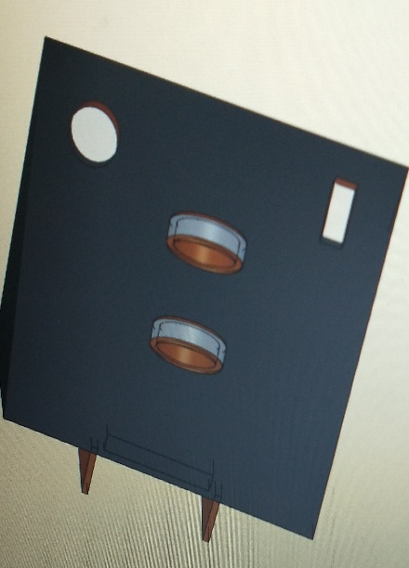

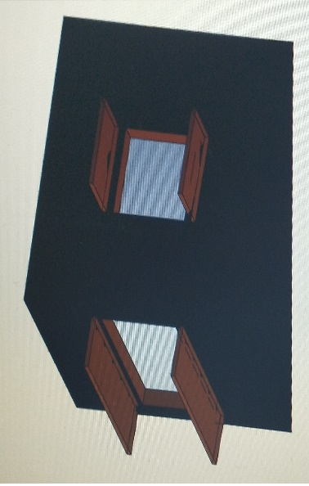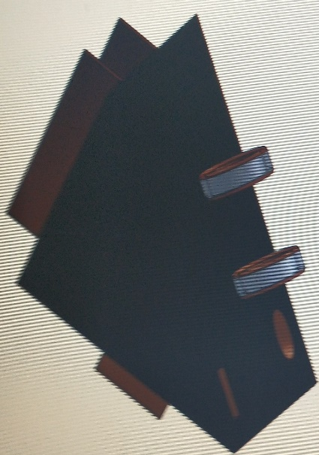

FIGURE NO. 12

FIGURE NO. 13

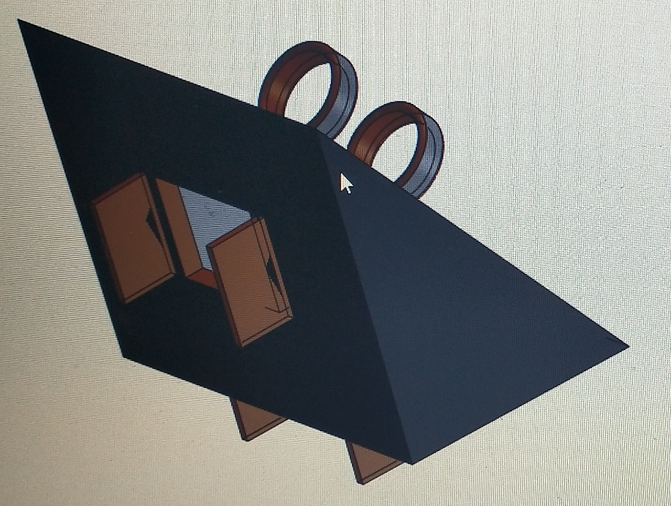

STEP-2: Most Possible compact Circuit-

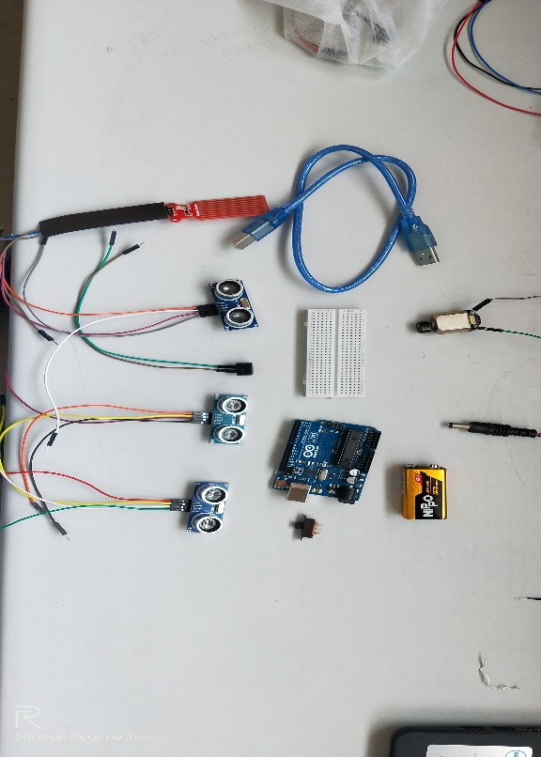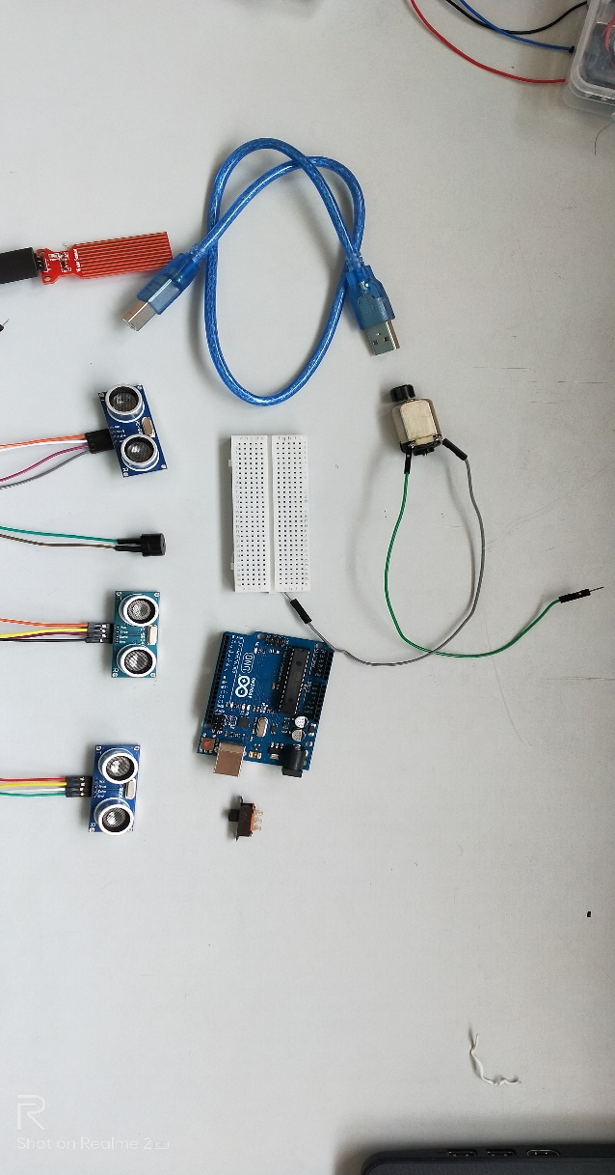

FIGURE NO. 15

FIGURE NO. 14

FIGURE NO. 16

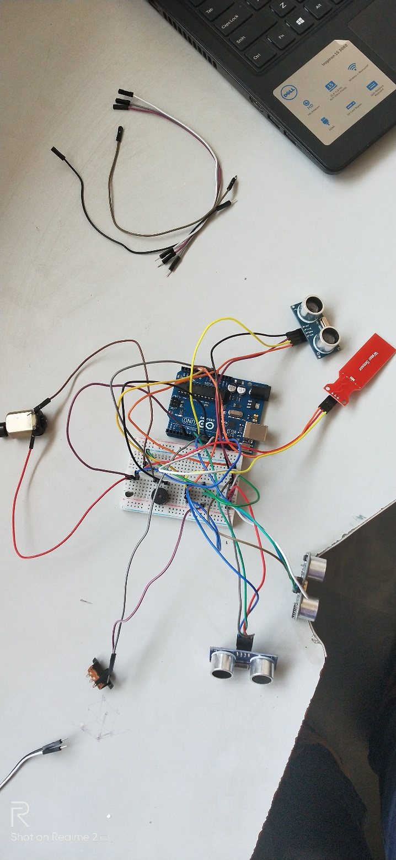

STEP-3: Casing Template Cut-Out-

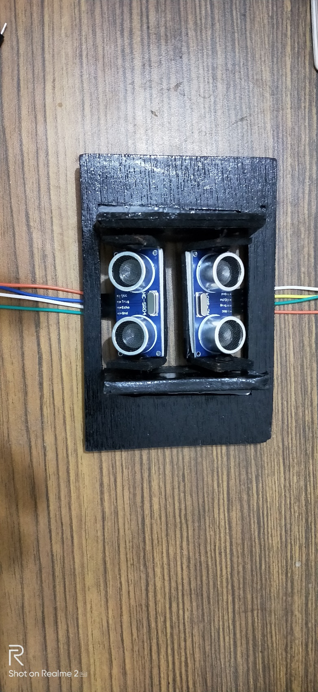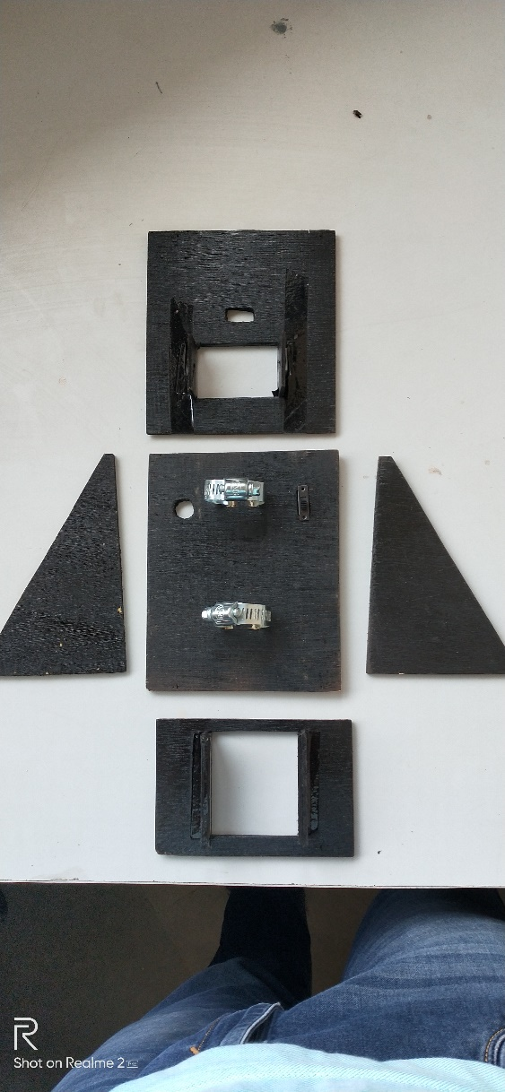

FIGURE NO. 18

FIGURE NO. 17

STEP-4: Final Assembly of all components-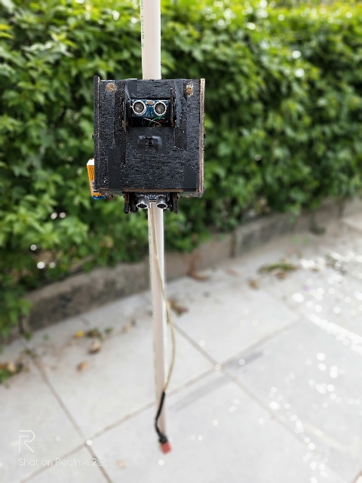

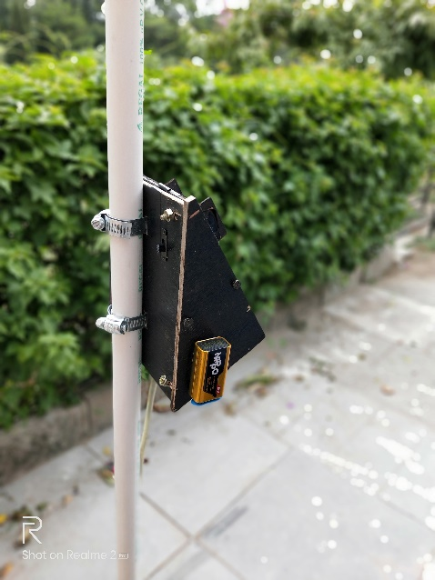

FIGURE NO. 19

FIGURE NO. 20

**GANTT CHART**

**10.06.19** – Presented the final ppt regarding the project.

**11.06.19** - Proper Testing of individual sensors

**12.06.19** – Inspection of former designs and other calculations.

**13.06.19** – Finalized the sensors/materials to be used

**14.06.19** – Finalized the programming code for the Arduino.

**15.06.19** – Tested the complete circuit and finished all calculations regarding the casing.

**16.06.19** – Prepared the most compact circuit possible.

**17.06.19** – Tested the programming code with the circuit.

**18.06.19** – Assembled the casing templates together.

**19.06.19** – Performed the proper testing of the circuit and did needful changes.

**20.06.19** – Finally, calibrated all the sensors at angles for desired results.

**COST ANALYSIS**

|  |  |  |
| --- | --- | --- |
| **COMPONENTS** | **QUANTITY** | **PRICE INR** |
| **Arduino Uno** | **1** | **340** |
| **Ultrasonic Sensors (HC-SR04)** | **3** | **170** |
| **Water Sensor** | **1** | **70** |
| **Vibration Motor** | **1** | **35** |
| **Breadboard** | **1** | **40** |
| **Buzzer** | **1** | **15** |
| **Rubber Tubing** | **1** | **10** |
| **9V Battery (power supply)** | **1** | **25** |
| **Jumper Wires** | **1 Set** | **50** |
| **Slide Switch** | **2** | **10** |
| **Casing of the device including all fitments** | **1** | **90** |
| **TOTAL** |  | **855** |

**INDIVIDUAL WORK DISTRIBUTION REPORT**

1. ) NIKHIL GOGNA –

* Tested all the ultrasonic sensors.
* Calculations regarding casing.
* Finalizing the Casing material to be used.
* To check upon progress log daily, and maintain a proper progress report.

1. ) MANISH –

* Tested PIR sensor.
* All the calculations related to mounting of ultrasonic sensors.
* Finalizing the circuit diagram.
* To finalize the possible, most compact programming code.

1. ) MANAN MITTAL –

* Tested Thermal sensor.
* To come up with feasible design with lowest possible size or weight.
* Making the simplest/neat possible circuit.

1. ) SAHIL SURYAVANSHI –

* Tested various outputs of vibration motor and buzzer.
* To come up with best ways of mounting various sensors.
* To decide the clamp mounting on the device.

1. ) TEAM AS A WHOLE-

* Proper testing and inspection of sensors in various modes and situations covering almost all possible real-life situations.

**RESULTS & DISCUSSIONS**

We here proposed a Blind Stick Assistance Device that allows visually challenged people to navigate with ease using advanced technology. The device is integrated with Arduino Uno along with various sensors including Ultrasonic Sensor, Water Sensor which altogether can detect obstacles like obstructions, potholes & water puddles in the person’s pathway.

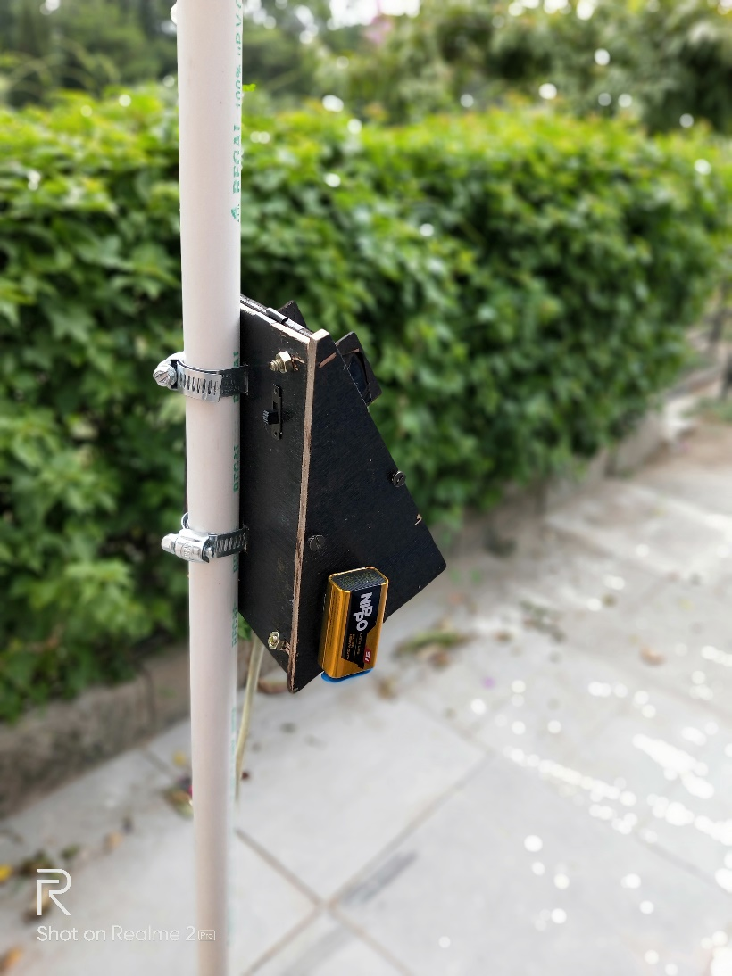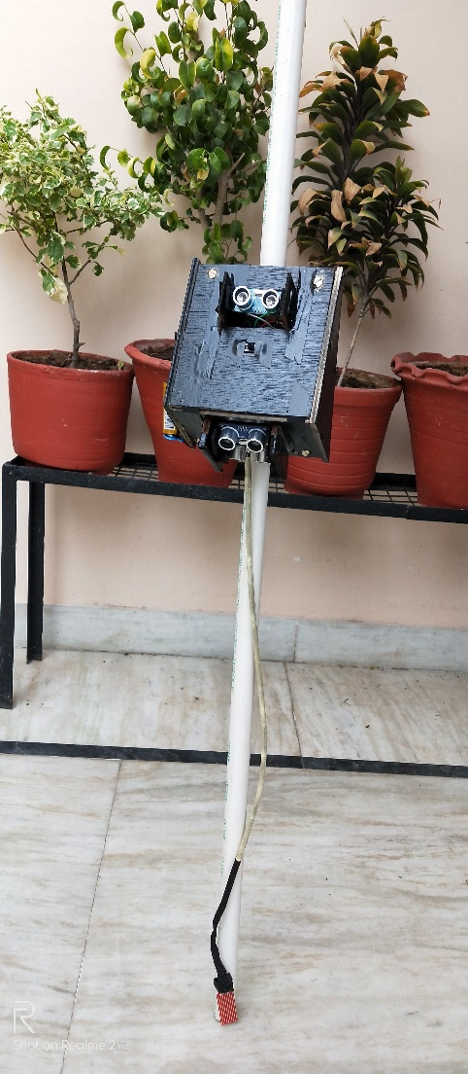

FIGURE NO. 21

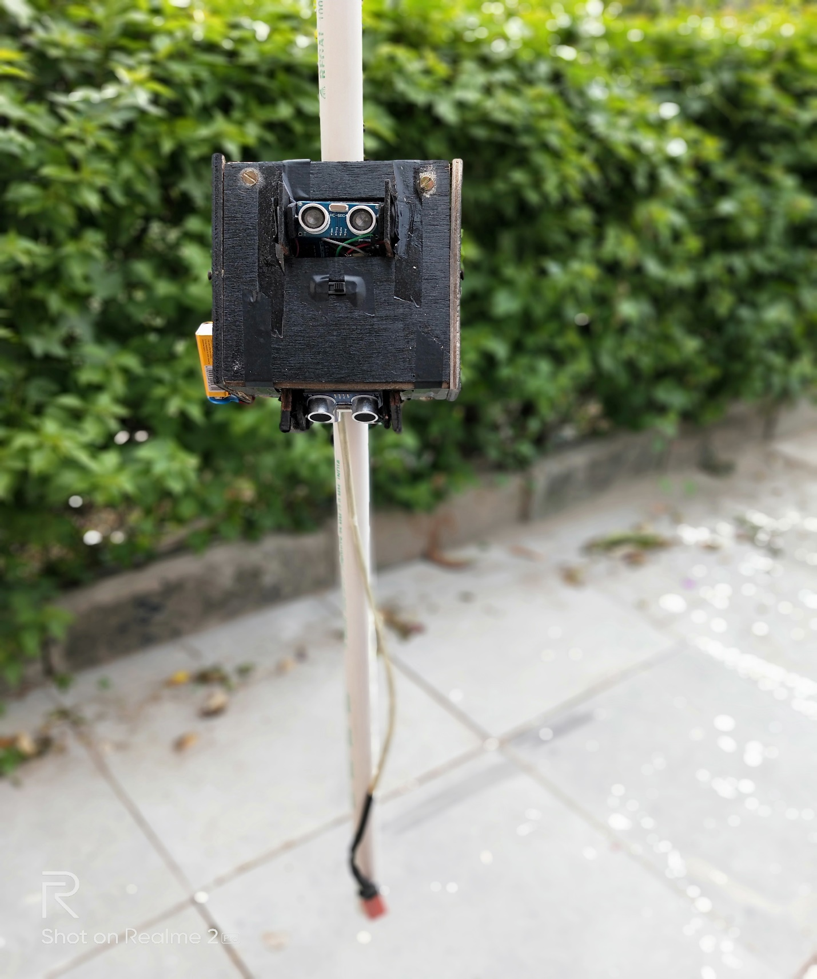

FIGURE NO. 22

**CONCLUSION**

It is worth mentioning at this point that the aim of this study which is the design and implementation of a smart walking stick for the blind has been fully achieved. The Smart Stick acts as a basic device for the coming generation of more aiding devices to help the visually impaired to navigate safely both indoor and outdoor. It is effective and affordable. It leads to good results in detecting the obstacles on the path of the user in a range of one meter sphere.This system offers low-cost, reliable, portable, low power consumption and robust solution for navigation with obvious short response time. Though the system is hard-wired with sensors and other components, it's light in weight. Further aspects of this system can be improved via wired connectivity between the system components.While developing such an empowering solution, visually impaired and blind people in all developing countries were on top of our priorities. The device constructed in this work is only capable of detecting obstacles and water. Holes can also be detected using this device nor the nature of obstacle. Therefore, a better device can be constructed using ultrasonic sensors, Arduino Uno and other devices that employ audio commands to alert the user of what is in his path of movement.

Our device can fit almost all types of existing regular blind sticks. People need not to buy the whole costly package including a stick, they can fit the device on their sticks with the help simple and easy Metal Clamps.

Currently, the project lacks a full integrated backend to make it function out of the box without pre-configuration. The ultrasonic sensor itself requires more development/testing to ensure that the end user can intuitively and without failure, use the interface. To achieve the out of box performance, the process of being able to connect to any sensor interface device without large amounts user interaction is required, meaning configuring the compact circuit as well as specific ones for the desired results. Once data can be reliably sent to and read by Arduino, the ability to view data in analog can be implemented for proper prototyping.

**BIBLIOGRAPHY**

<https://en.wikipedia.org/wiki/Arduino_Uno>

<https://en.wikipedia.org/wiki/Ultrasonic_transducer>

<https://en.wikipedia.org/wiki/Water_detector>

<https://www.arduino.cc/en/Guide/ArduinoUno>

<https://www.tutorialspoint.com/arduino/arduino_water_detector_sensor.htm>

<https://howtomechatronics.com/tutorials/arduino/ultrasonic-sensor-hc-sr04/>

<https://www.precisionmicrodrives.com/content/how-to-drive-a-vibration-motor-with-arduino-and-genuino/>

<https://www.instructables.com/circuits/arduino/projects/>

<https://create.arduino.cc/projecthub/SURYATEJA/use-a-buzzer-module-piezo-speaker-using-arduino-uno-89df45>

<https://pdfs.semanticscholar.org/d726/725512c9a14389c7bdfb5e9186deaba2f018.pdf>

**REMARKS**

**__________________________________________________________________________________________________________________________________________________________________________________________________________________________________________________________________________________________________________________________________________**